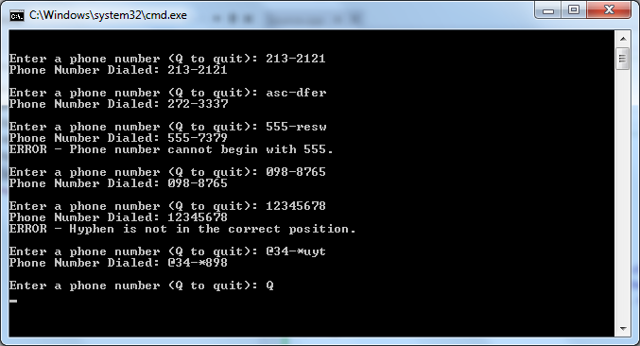

// ---------------------------------------------------------------

// Developer: Kevin Nguyen

// Date Written: 5/28/15

// Purpose: Phone-Dialing Program

// ---------------------------------------------------------------

#include<iostream>

#include<string>

#include<iomanip>

usingnamespacestd;

intReadDials(char, char, char, char, char, char, char, char); // Function Prototype

voidToDigit(char, char, char, char, char, char, char, char);

voidAcknowledgeCall(char, char, char, char, char, char, char, char);

int x;

void main()

{

char a, b, c, d, e, f, g, h;

while(true){

cout<<"\n\nEnter a phone number (Q to quit): ";

cin>> a >> b >> c >> d >> e >> f >> g >> h;

while (true){

ReadDials(a, b, c, d, e, f, g, h); // Calls function

if (x == -1){

cout<<"\nERROR - An invalid character was entered.\n\n";

cout<<"Enter a phone number (Q to quit): ";

cin>> a >> b >> c >> d >> e >> f >> g >> h;

ReadDials(a, b, c, d, e, f, g, h);

}

elseif (x == -2){

cout<<"\nERROR - Phone number cannot begin with 0.\n\n";

cout<<"Enter a phone number (Q to quit): ";

cin>> a >> b >> c >> d >> e >> f >> g >> h;

ReadDials(a, b, c, d, e, f, g, h);

}

elseif (x == -3){

cout<<"\nERROR - Phone number cannot begin with 555.\n\n";

cout<<"Enter a phone number (Q to quit): ";

cin>> a >> b >> c >> d >> e >> f >> g >> h;

ReadDials(a, b, c, d, e, f, g, h);

}

elseif (x == -4){

cout<<"\nERROR - Hyphen is not in the correct position.\n\n";

cout<<"Enter a phone number (Q to quit): ";

cin>> a >> b >> c >> d >> e >> f >> g >> h;

ReadDials(a, b, c, d, e, f, g, h);

}

if (x == -5){

break;

}

else {

break;

}

}

}

system("pause");

}

// Function Definitions

intReadDials(chara, charb, charc, chard, chare, charf, charg, charh)

{

ToDigit(a, b, c, d, e, f, g, h);

if (a == '!')

{

x = -1;

return x;

}

elseif (a == '0')

{

x = -2;

return x;

}

elseif (a&&b&&c == '5'){

x = -3;

return x;

}

elseif (d != '-')

{

x = -4;

return x;

}

elseif (a == 'Q')

{

x = -5;

return x;

}

else{

return 0;}

}

voidToDigit(chara, charb, charc, chard, chare, charf, charg, charh)

{

a = toupper(a);

b = toupper(b);

c = toupper(c);

e = toupper(e);

f = toupper(f);

g = toupper(g);

h = toupper(h);

switch (a)

{

case'A':

case'B':

case'C':

a = '2';

break;

case'D':

case'E':

case'F':

a = '3';

break;

case'G':

case'H':

case'I':

a = '4';

break;

case'J':

case'K':

case'L':

a = '5';

break;

case'M':

case'N':

case'O':

a = '6';

break;

case'P':

case'Q':

case'R':

case'S':

a = '7';

break;

case'T':

case'U':

case'V':

a = '8';

break;

case'W':

case'X':

case'Y':

case'Z':

a = '9';

break;

default:

break;

}

switch (b)

{

case'A':

case'B':

case'C':

b = '2';

break;

case'D':

case'E':

case'F':

b = '3';

break;

case'G':

case'H':

case'I':

b = '4';

break;

case'J':

case'K':

case'L':

b = '5';

break;

case'M':

case'N':

case'O':

b = '6';

break;

case'P':

case'Q':

case'R':

case'S':

b = '7';

break;

case'T':

case'U':

case'V':

b = '8';

break;

case'W':

case'X':

case'Y':

case'Z':

b = '9';

break;

default:

break;

}

switch (c)

{

case'A':

case'B':

case'C':

c= '2';

break;

case'D':

case'E':

case'F':

c= '3';

break;

case'G':

case'H':

case'I':

c= '4';

break;

case'J':

case'K':

case'L':

c= '5';

break;

case'M':

case'N':

case'O':

c= '6';

break;

case'P':

case'Q':

case'R':

case'S':

c= '7';

break;

case'T':

case'U':

case'V':

c= '8';

break;

case'W':

case'X':

case'Y':

case'Z':

c= '9';

break;

default:

break;

}

switch (e)

{

case'A':

case'B':

case'C':

e= '2';

break;

case'D':

case'E':

case'F':

e= '3';

break;

case'G':

case'H':

case'I':

e= '4';

break;

case'J':

case'K':

case'L':

e= '5';

break;

case'M':

case'N':

case'O':

e= '6';

break;

case'P':

case'Q':

case'R':

case'S':

e= '7';

break;

case'T':

case'U':

case'V':

e= '8';

break;

case'W':

case'X':

case'Y':

case'Z':

e= '9';

break;

default:

break;

}

switch (f)

{

case'A':

case'B':

case'C':

f= '2';

break;

case'D':

case'E':

case'F':

f= '3';

break;

case'G':

case'H':

case'I':

f= '4';

break;

case'J':

case'K':

case'L':

f= '5';

break;

case'M':

case'N':

case'O':

f= '6';

break;

case'P':

case'Q':

case'R':

case'S':

f= '7';

break;

case'T':

case'U':

case'V':

f= '8';

break;

case'W':

case'X':

case'Y':

case'Z':

f= '9';

break;

default:

break;

}

switch (g)

{

case'A':

case'B':

case'C':

g= '2';

break;

case'D':

case'E':

case'F':

g= '3';

break;

case'G':

case'H':

case'I':

g= '4';

break;

case'J':

case'K':

case'L':

g= '5';

break;

case'M':

case'N':

case'O':

g= '6';

break;

case'P':

case'Q':

case'R':

case'S':

g= '7';

break;

case'T':

case'U':

case'V':

g= '8';

break;

case'W':

case'X':

case'Y':

case'Z':

g= '9';

break;

default:

break;

}

switch (h)

{

case'A':

case'B':

case'C':

h= '2';

break;

case'D':

case'E':

case'F':

h= '3';

break;

case'G':

case'H':

case'I':

h= '4';

break;

case'J':

case'K':

case'L':

h= '5';

break;

case'M':

case'N':

case'O':

h= '6';

break;

case'P':

case'Q':

case'R':

case'S':

h= '7';

break;

case'T':

case'U':

case'V':

h= '8';

break;

case'W':

case'X':

case'Y':

case'Z':

h= '9';

break;

default:

break;

}

AcknowledgeCall(a, b, c, d, e, f, g, h);

}

voidAcknowledgeCall(chara, charb, charc, chard, chare, charf, charg, charh)

{

cout<<"Phone Number Dialed: "<<a<<b<<c<<d<<e<<f<<g<<h;

}